Friday 22nd October 2021

Prize winners this week:

Class 1: Fynn for super attitude with phonics.

Class 2: Ernie for brilliant concentration and making great links in his learning.

Class 3: Grace for building confidence and a fantastic attitude in class.

Class 4: Aliyah for working really hard.

CLASS 1: Most of the children are ready for a little break. They have worked really hard. Reception children have been blending some two and three letter words. They have used their phoneme frames and knowledge of how the phoneme sound.Y1 children have been learning about less than, greater than and equal to. Language associated with this is sometimes tricky at this stage so when at home ask your child if its “bigger, larger, or more, then that’s greater.” Likewise equal to is the same and less than means smaller, fewer not as many. We have discussed farming this week and the many jobs on a farm. Linking farming to harvest we have also chatted about the gathering of crops and some new planting at this time of year. Have a lovely break everyone.
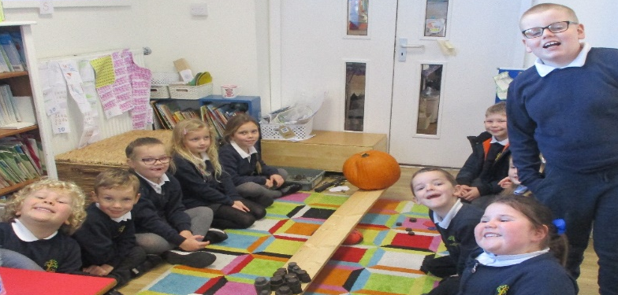
CLASS 2: This week in class 2 we have enjoyed our Autumnal mini project. We have been foraging on the field and gathering seeds. We sorted them into groups depending on how their seeds were spread. We carried out fair tests to see which was best at sticking to fur and clothes. We have made clay hedgehogs and learned how to “pinch” clay to make a nose and put a thumb depression for the eyes. We have also been finding the rhyming words in our autumn poems which we also enjoyed performing. We have made pumpkin soup and used a balance plank to measure the pumpkin before and after we scooped out the inside.

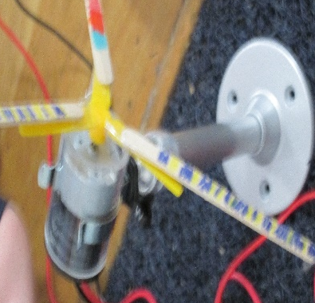
CLASS 3: This week Class 3 have been super creative. We have used STEAM skills to further explore how wind turbines work and discussed why the shape of turbine blades are important to catch the wind. We thought about the materials, weight, and number of blades for future designs to trial. Class 3 have started using their place value knowledge to add and subtract multiples of 100, picking out key information and talking about mathematical language (add, total, subtract, take away, minus). We looked at features of poetry (Haikus) and practiced counting syllables, as well as continuing to practice and build our reading comprehension skills. Well done Class 3!

CLASS 4: Class 4 have had a very busy term and have all worked extremely hard. I hope everyone enjoys their well-deserved rest and has a brilliant half term. Well done class 4 keep up the good work! 0
LOST PROPERTY In class 1 we have a Nutmeg brand cardigan and George brand cardigan, a white Lowca logo polo top and a pink Hoodie (Next, age 10) if you are missing these items please get in touch. PLEASE MAKE SURE YOU PUT NAMES IN ALL YOUR CHILD’S CLOTHING AND CHECK IT IS STILL THERE EVERY FEW WEEKS AS IT CAN TEND TO WASH OFF.
General information
DATE AND TIME | EVENT
Mon 1/11/21 | Return to school, 8.50am start
Mon 15/11/21 | KS1 toys workshop Tullie house
Fri 19/11/21 | Children in need (More to follow)
Mon 13/12/21 | Nativity rehearsal (More to follow)
Tue 14/12/21 | Nativity at Church (More to follow)
Please make sure all PE kits come back into school on the Monday we return. Please make sure your child’s name is on their PE kit.

