Friday 29th April 2022.

Prize winners this week: Class 1: Thomas W and Mia - for their super spellings. Class 2: Luca - for amazing progress in Swimming. Class 3: Grace - for her super research skills and her kindness to all her classmates. Class 4: Aliyah - for perfecting telling the time and using the 24hr clock and for her hard work in maths.

Class 1: Class1 this week are enjoying our new topic of Beaches. In History we have looked at Deep Sea Explorers like Jacque Cousteau, Sylvia Earle and Robert Ballard. We have also discussed some of the technologies the explorers have used over time. Yr1 have been busy working with 2’s and 3’s, looking for patterns and finding equal and unequal groups. Reception children are continuing to work with numbers between 10 and 20. Well done to all year1 children – 100% with their spellings!
CLASS 2: This week we have been learning about position and giving directions. We made a chalk road and guided our robot person along it using right, left, forwards and backwards. In art we have been exploring oil past6els to create a version of” the wave”. In English we have written stories paying particular attention to full stops, capitals, lists, and apostrophes.
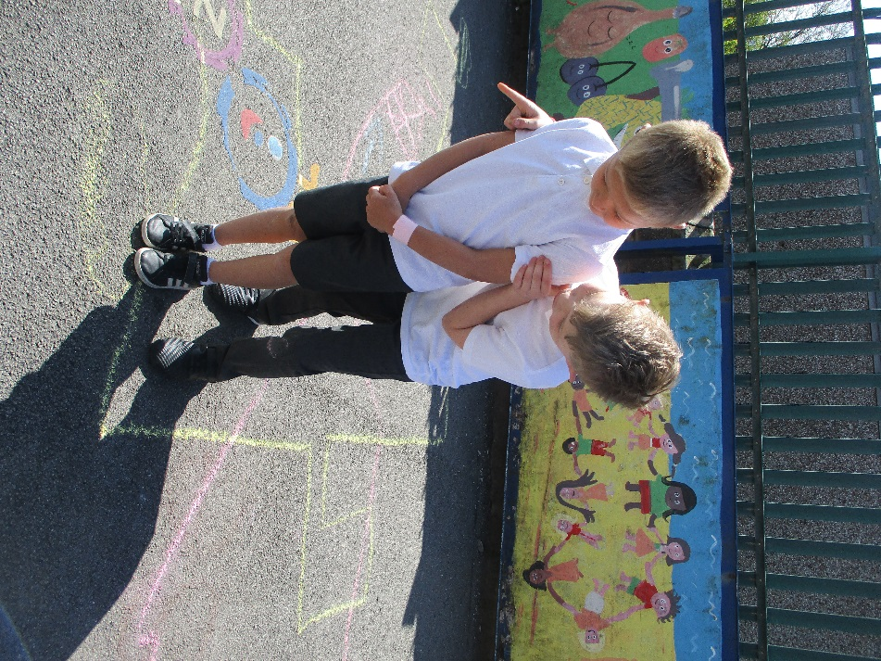

CLASS 3: In Class 3 this week we have explored different scientists that have changed the world. The children used research skills to find information about when and how they lived, their influences, discoveries and how their work influenced the world. They then used their information to create fact file posters to present and discuss with the class and answer questions to show their knowledge and understanding. Class 3 continue to build their knowledge of fractions and have practiced converting between mixed and improper fractions, to then add and subtract with same denominators. All week the children have had a super time swimming. They all remembered their skills from last time and have grown further in confidence, as well as shown good listening and practiced safety skills for rivers. In Science we have looked at forces and friction, with the focus on the work of Sir Isaac Newton. We set up and carried out an investigation on how different materials affect friction of a moving toy. The children made predictions and wrote up their findings. We have also looked at influential musicians and composers, looking at Johann Strauss. We discussed how the Blue Danube influenced the waltz and how people still dance to classical music, as well as appreciating and listening to the different instruments and sections used to create the piece. Well done Class 3! Remember to go on Sumdog and Spelling shed for homework to help practice our Math's skills an read every night
CLASS 4: This week class 4 have planted out their homegrown broad beans and eight buckets of Charlotte potatoes! They have really enjoyed their week of swimming and managed their self-rescue in a “stormy sea” pool on Thursday. The year 6 have been working very hard on their SATs revision. The year 5 have finished their reading of Frankenstein and have started reading Kensuke’s Kingdom by Michael Morpurgo. They have also studied Nelson Mandela and are learning about Jazz music. Year 5 and 6 will be having a Stem day on May 4th. Please can the children dress as a famous person. Please don’t buy a costume, just put one together from your ordinary clothes. * Grace Robson and Bella Brown

General information:
DATE AND TIME | EVENTS
Monday 9th- Thursday 12th May | ** SATS WEEK **
Wednesday 4th May | Year 5 and 6 dress up as a famous person for stem day - organized by Grace and Isabella.
Wednesday 25th May | Jubilee Lunch- The only option available on Orion is Fish and Chips. If your child does not like this choice please send them in with a packed lunch. If your child does want the Orion lunch then you must order it as normal.
Friday 27th May | Finish for half term at 3.15pm, back in Monday 6th June 8.50am
Wednesday 8th June | KS2 Glasgow Science Centre Visit (years 3, 4, 5 and 6) leaving school promptly at 07.30am. The children must take a packed lunch. Cost to pupils is £5.00. More details to follow.
Wednesday 8th June | KS1 Are visiting The Beacon in Whitehaven. All children must bring a packed lunch. More details to follow.
Thursday 23rd June | Reception, Y1 and Y2 visit to Maryport aquarium. More details to follow.
Wednesday 29th June | Careers day at Lowca School, being held in the school hall, more details to follow.
Wednesday 6th July | St Benedicts taster day. Pupils will be picked up from Lowca and returned for end of school day.
Monday 11th July | Pupil reports out to parents sometime this week.
Wednesday 20th July | BREAK UP FOR SUMMER HOLIDAYS. Finish at 3.15pm. Start back 08.50am Wednesday 7th September.

